**Welcoming children on the first day of ECCD Lab Nursery school 2024-2025**

ECCD Lab reopened on 8th July 2024. Total 41 children joined for Pre-Nursery and Nursery classes.

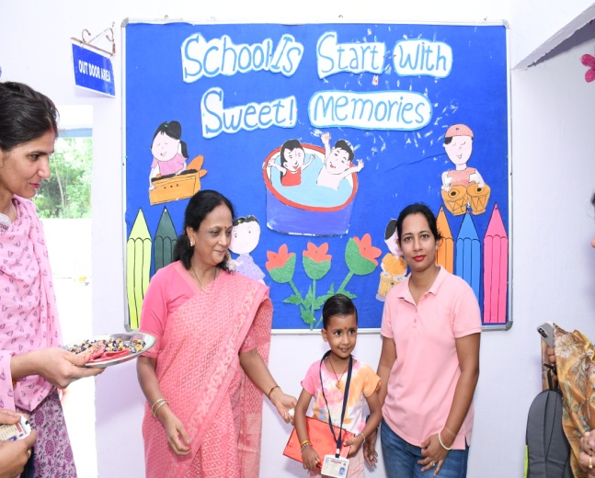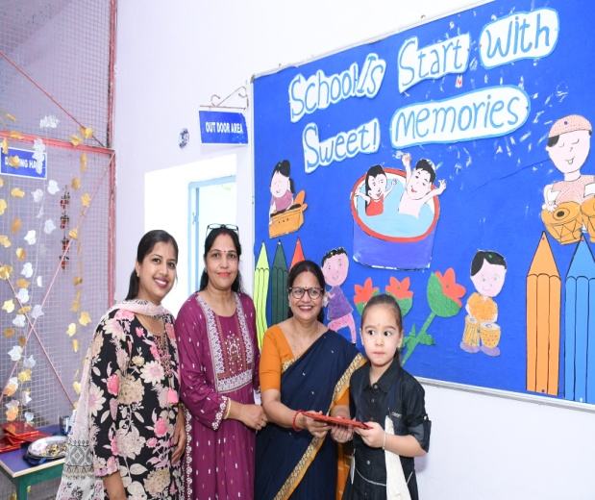

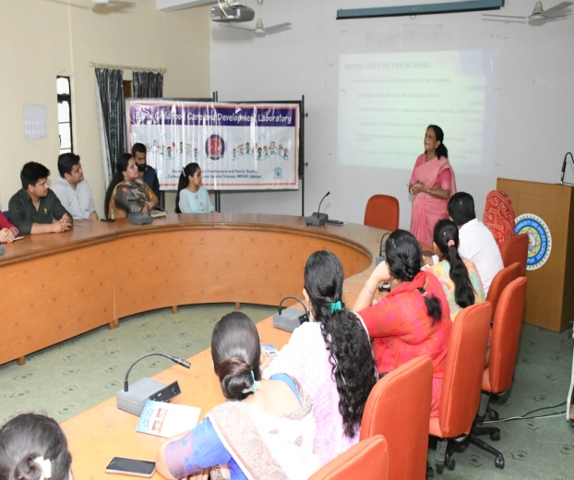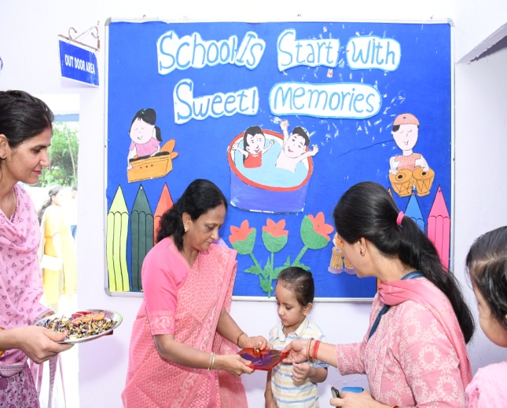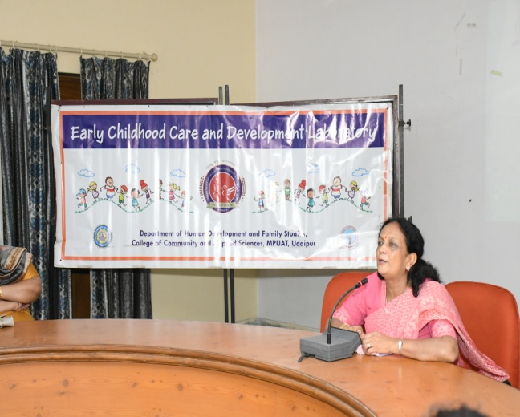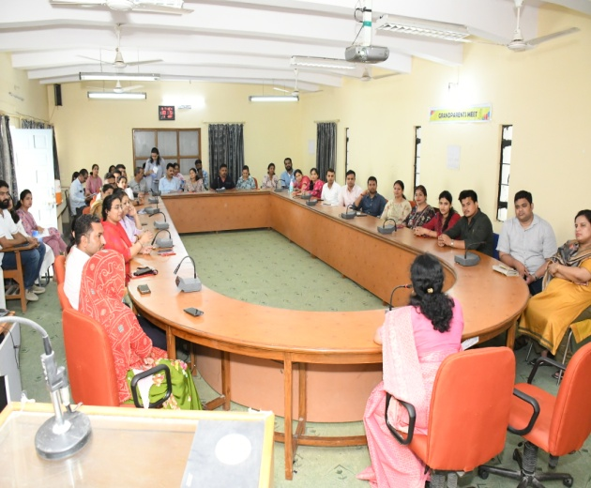

An orientation programme for parents was also organized .The head of the department Dr.Suman Audichya welcome the parents. A small presentation was given to parents on **“How to prepare children for pre-school”** Parents were also oriented regarding general rules and regulations in the ECCD Lab. A folder on **“First look to your child’s school** was also distributed to parents.